

June 11, 2025

**Shopify Sales Dashboard**

**Table of Contents**

Contents

1. Introduction 3

2. Background and Objective 3

3. Methodology 4

3.1 Data Collection and Preparation: 4

3.2 Data Cleaning and Transformation: 4

3.3 KPI Calculation and PivotTable Creation: 4

3.4 Dashboard Design and Visualization: 5

3.5 Visual Aesthetics and Layout: 8

3.6 Interactivity: 8

4 Conclusion 9

# Introduction

This report details the creation and functionality of an interactive Excel dashboard designed to provide comprehensive insights into sales performance. Utilizing data from the CSV file, the dashboard transforms raw Shopify transactional data into actionable key performance indicators (KPIs) and visualizations. The aim is to offer an at-a-glance view of sales trends, product performance, and operational efficiency, enabling users to monitor metrics in real-time and identify areas for improvement.

# Background and Objective

The project was initiated to leverage existing sales data, contained within an Excel-compatible CSV file, to build a robust and user-friendly analytical tool. The primary goal was to move beyond raw data lists and create a dynamic dashboard that simplifies complex sales information.

**Key objectives included:**

* 1. **Presenting Core Sales Performance Metrics:** To display critical KPIs such as Total Orders, Total Sales, Total Quantities Sold, Shipping Cost, Total Discount, and Outstanding Amount in an easily digestible format.
  2. **Analyzing Trends Over Time:** To visualize monthly trends for Total Sales, and Number of Orders done in each month to identify patterns and seasonal variations.
  3. **Breaking Down Performance by Category:** To analyze sales and order data across key dimensions like Warehouse, Shipping Province, Product, and Financial Status.
  4. **Enhancing User Interactivity:** To incorporate Excel's interactive features, such as slicers and a timeline, allowing users to filter and explore data dynamically for more granular insights.
  5. **Optimizing for Clarity and Aesthetics:** To design a dashboard layout that is clean, intuitive, and visually appealing, ensuring users can quickly interpret and act on the information presented.

# Methodology

The development of the Sales Performance Dashboard in Excel involved a structured approach, encompassing data preparation, KPI calculation, PivotTable and PivotChart creation, and dashboard design.

## Data Collection and Preparation:

* + 1. The project utilized the orders_export_1.csv file as the primary data source.
    2. **The raw CSV data was imported into Excel and formatted as an Excel Table (Sales Data)** to ensure dynamic updates and ease of use with PivotTables.

## Data Cleaning and Transformation:

* + 1. The "Created at" column was verified and formatted correctly as a date to enable time-based analysis.
    2. Blank entries in the "Financial Status" column were identified and replaced with "paid" to consolidate related data points, ensuring accurate aggregation of financial statuses.
    3. The "Location" column was cleaned by renaming (blank) entries to "Website" and filtering/removing the erroneous "Shop location" and “Red Stag Fulfillment” entries directly within the PivotTable to improve data clarity and accuracy for warehouse-based analysis.
    4. A new calculated column, "**Warehouse**," was added to the source Sales Data table. This column was created to compute the total sales and orders from each of the warehouse.

## 3.3 KPI Calculation and PivotTable Creation:

Multiple PivotTables were created, each dedicated to a specific set of KPIs or a single KPI for charting flexibility:

* + 1. **Summary Metrics:** A PivotTable was configured to calculate Count of Names (Id/Total Orders), Sum of Lineitem quantity (Quantity Sold), Sum of Total (Total Sales), Sum of Shipping (Total Shipping Cost), Sum of Discount Amount (Total Discount), and Sum of Outstanding Balance (Outstanding Amount).
    2. **Monthly Trends:** Separate PivotTables were created for "Total Sales by month" (Sum of Total grouped by Created at), "No. of Orders by Month" (Count of Id grouped by Created at), and "Average Order Value by month" (using a PivotTable Calculated Field: = Total / Id). This separation ensured individual charting for each trend.
    3. **Categorical Breakdowns:** Individual PivotTables were set up for "Total Sales by Warehouse" (Sum of Total by Location), "Order by Warehouse" (Count of Id by Location), "Shipping Cost for Provinces" (Sum of Shipping by Shipping Province Name), "No. of Orders for Provinces" (Count of Id by Shipping Province Name), "Orders by Product" (Count of Id by Lineitem name), "Total Sales by Product" (Sum of Lineitem Total Sales by Lineitem name), and "Order by Financial Status" (Count of Id by Financial Status).

## Dashboard Design and Visualization:

* + 1. **Dashboard:**

A dedicated "Dashboard" sheet was created for the final presentation.

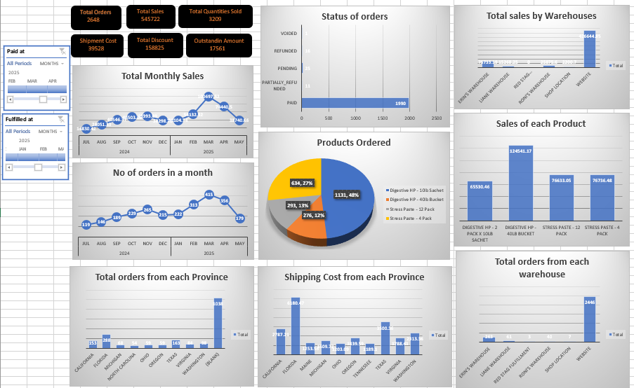

Figure 3.4.1 (Shopify Sales Dashboard)

* + 1. **Key summary KPIs:**

Key Summary KPIs were extracted from their respective PivotTables and displayed prominently using linked cell references within custom-designed shapes, providing a "card" like visual.

**Overall Sales Performance:** The total sales figure for the period is **$458,751.64**. This represents the cumulative revenue generated from all orders, providing a foundational understanding of the business's financial scale. Other key summary metrics include a **Total Orders** count of **2,471**, **Quantity Sold** of **2,808** units, **Total Shipping Cost** of **$36,962.65**, **Total Discount** applied of **$109,307.20**, and an **Outstanding Amount** of **$16,493.77**.

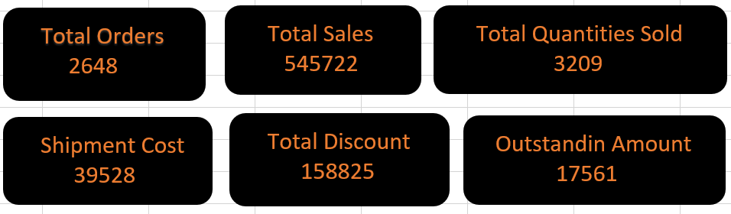

Figure 3.4.2 (Key summary KPIs)

* + 1. **PivotCharts:**

1. **Monthly Trends:** PivotCharts were generated from each of the detailed PivotTables, including line charts for monthly trends and a timeline for interactivity.

Over the period from **2024 to 2025**, the **Number of Orders By Month** shows a general upward trend through 2024, peaking towards the end of the year, and then fluctuating in 2025 with a peak in March and a subsequent dip. The **Average Order Value by Month** (as represented by the 'Average Value of Order' column) shows slight fluctuations, indicating consistent average transaction sizes despite variations in order volume.

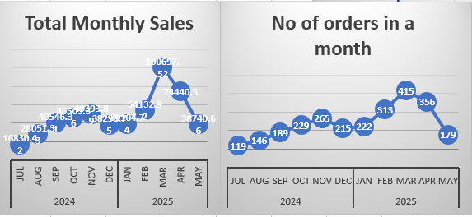

Figure 3.4.3.A (Monthly Trends)

1. **Warehouses and Products:** PivotCharts were generated from each of the detailed PivotTables, including bar and column charts for categorical breakdowns.
   1. **Top Performing Warehouses/Locations:**
      * The **Website** is the dominant sales channel, contributing **$426,644** in sales from **2,446** orders.
      * Among physical locations, **Erin's Warehouse** is the top performer with **$75,733.75** in sales from **263** orders.
      * **Roni's Warehouse** and **Liane Warehouse** follow with sales of **$25875.10** (40 orders) and **$5,268.85** (61 orders) respectively.
   2. **Product Performance:**
      * Top-selling products by **revenue** include:
        + **Stress Paste - 12 pack**: $76,633.
        + **Stress Paste - 4 pack**: $76736.
        + **Digestive HP - 40lb Bucket**: $124,541.
        + **Digestive RP - 2 pack x 10lb Sachet**: $65,530.
      * Top products by **quantity sold** include:
        + **Digestive HP - 10lb Sachet**: 1,131 units
        + **Stress Paste - 4 Pack**: 634 units
        + **Digestive HP - 40lb Bucket**: 276 units

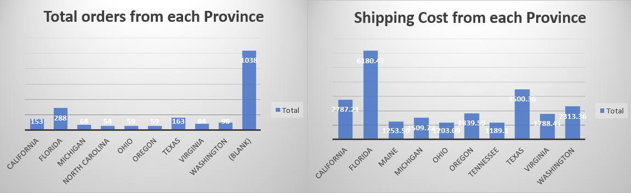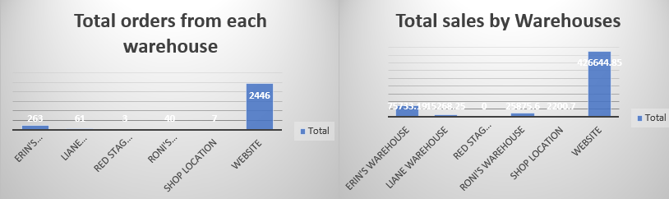

Figure 3.4.3.B (Warehouse and Product Categorical Breakdowns)

1. **Provincial and Financial:** PivotCharts were generated from each of the detailed PivotTables, including bar and column charts for categorical breakdowns.
2. **Financial Status Distribution:** The majority of orders are **paid**, which now includes previously blank entries resulting from data cleaning and consolidation, thereby strengthening the primary revenue stream. Other statuses represent smaller proportions: **pending,** (**refunded** **partially_refunded**, and **voided**. Added with a slicer for smooth interactivity.

Figure 3.4.3.C (Provincial and Financial Categorical Breakdowns)

## 3.5 Visual Aesthetics and Layout:

The dashboard was designed with a clean, materialistic aesthetic, utilizing subtle background and shapes with soft shadows to give elements a sense of elevation.

Charts were formatted with no fill or outline to integrate seamlessly with the underlying shapes.

Consistent color palettes, clear titles, and readable fonts were applied throughout.

## 3.6 Interactivity:

**Timeline** inserted for key dimensions (Created at (Year, Quarter, Month), and **Slicers** for Location, Shipping Province Name, Financial Status, and Lineitem name) and connected to all relevant PivotTables and PivotCharts, enabling dynamic filtering and exploration of data.

# Conclusion

The Excel Sales Performance Dashboard successfully provides a comprehensive and interactive platform for monitoring and analyzing key sales metrics. By transforming raw data into clear, visually appealing, and interactive insights, the dashboard empowers users to track performance in real-time, understand underlying trends, and make informed decisions to optimize sales strategies and operational efficiency. The use of PivotTables, PivotCharts, and aesthetic design principles has resulted in a powerful and user-friendly analytical tool.